**EXPERIMENT-3**

**RC High and Low Pass Circuits for Square Input**

-----------------------------------------------------------------------------------------------------------------------------------------------------------------------------------------------------------------------------------------------------------------------------------------------------------------------------------------------

1. Design a High pass and low pass RC circuit for a given cut off frequency.
2. Verify the condition for which the High pass circuit acts as a differentiator.
3. Verify the condition for which the Low pass circuit acts as an integrator.
4. **Aim:**
5. **Specification:** Cutoff Frequency of the Circuit = 1.60 kHz.
6. DRB
7. Capacitors:0.1µF
8. CRO
9. DSO Probes
10. Function Generator
11. Bread board
12. **Hardware:**
13. **Theory:**

**RC High Pass Circuit as a differentiator:**

The Differentiator circuit converts or 'differentiates' a square wave input signal into high frequency spikes at its output.

In an RC circuit if we take the voltage drop across R, and if we keep RC time constant is very short compared to the time period of the input waveform we will be differentiating the square wave.

**RC Low Pass Circuit as a integrator:**

The Integrator is a circuit that converts or ‘integrates' a square wave input signal into triangular waveform output.

In an RC circuit if we take the voltage drop across C, and if we keep RC time constant is very large compared to the time period of the input waveform we will be integrating the square wave.

1. **Procedure:**
2. Connect the circuit as per the circuit diagram
3. Apply Sine Wave with 5 $V_{p−p}$ and 1.6KHz frequency using function generator and note down the i/p and o/p voltages and plot Frequency Response.
4. Apply 5 $V_{p−p}$ with 1.6KHz frequency using function generator , initially keep R small, slowly increase the R Value.
5. Observe the output in CRO.
6. Note the output wave form and calculate Rise and Fall Time for the different time constants: τ = T, τ >>T and τ <<T in Observation Table.
7. **Design:**

$$f_{c}=\frac{1}{2πRC}$$

C=0.1µF, R~=1KΩ, $f_{c}$ = 1.60 KHz

1. **Circuit schematic of each RC-filter and Frequency response model graphs:**

The frequency response of High pass and low pass filter need to be observed for given sinusoidal as input. Generate sinusoidal input signals of different frequencies from function generator, Cover a range of frequencies from very low (close to DC) to high frequencies. Logarithmic spacing of frequencies (octave or decade steps) is often used for better resolution, is the procedure to plot the frequency response plot.

1. **Frequency Response:**

**High Pass RC Circuit**

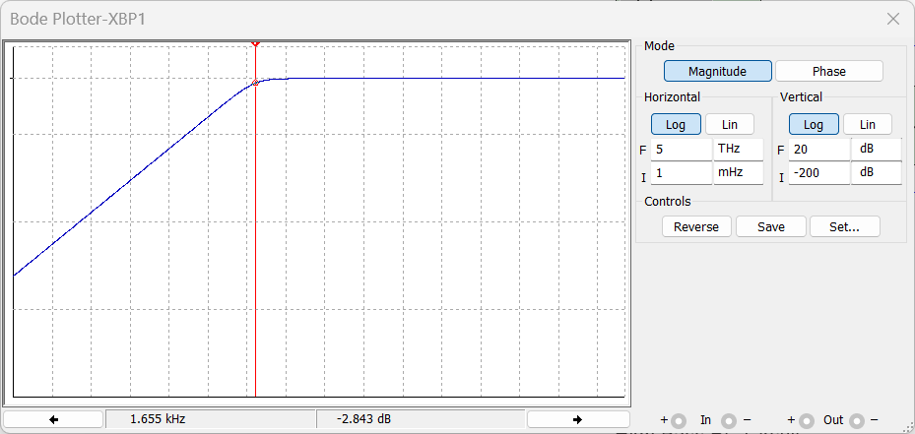

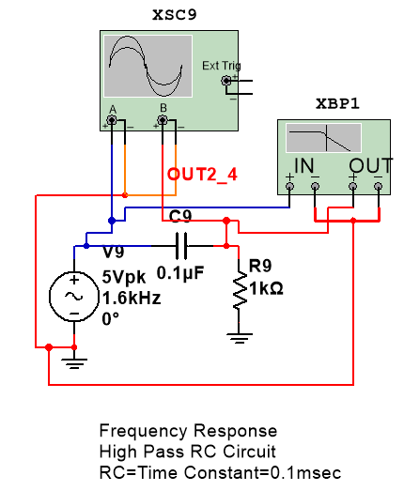

Figure 1. Frequency response of High pass RC circuit (RC=T=1*10^3*0.1*10^-6=0.1msec)

**Conclusion:**

From the above response we can conclude that for frequencies less than the cutoff frequency, the i/p signal is attenuated and for high frequencies the same i/p signal appears at the o/p terminal.

**Low Pass RC Circuit**

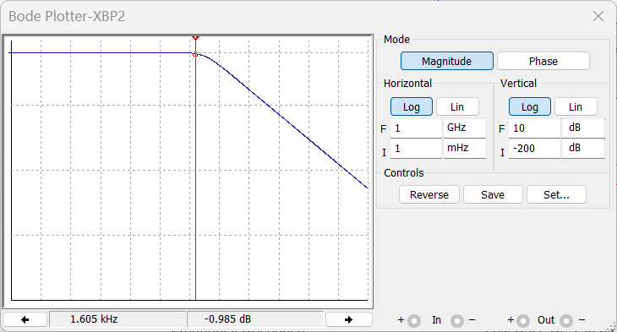

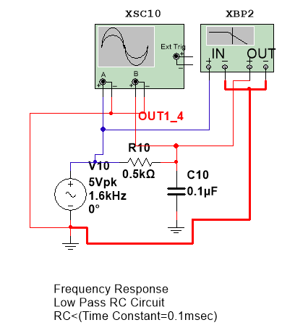

**.**

Figure 2. Frequency response of Low pass RC circuit (RC=T=1*10^3*0.1*10^-6=0.1msec)

**Conclusion:**

From the above response we can conclude that for frequencies greater than the cutoff frequency, the i/p signal is attenuated and for low frequencies the same i/p signal appears at the o/p terminal.

1. **Simulation Observations:**
2. **High Pass RC Circuit:**

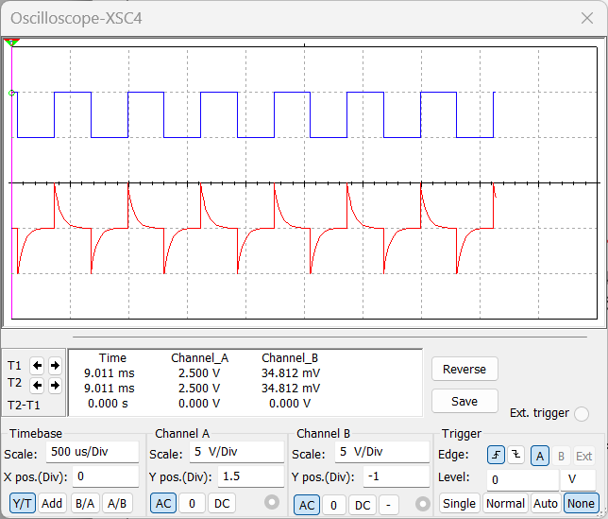

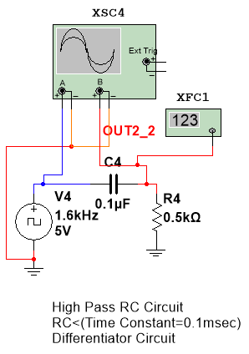

Figure 3. High pass RC when RC <T (DIFFERENTIATOR CIRCUIT) and transient response

Vout

**Conclusion:**

The above waveform depicts the differentiator behavior of RC Circuit, as we can see the input square wave is modified and produced high frequency spikes at its output. Here RC time constant is very small, so the charging/discharging of capacitor takes place in a short duration of time thus producing spikes at high Frequencies. As we decrease the RC value the sharpness of the spikes increases. Thus we can generate spikes waveforms using a High pass RC Circuit operating at RC<<τ.

[High Pass RC Circuit operating at RC<<τ = Spike Signal Generator]

1. **RC=T**

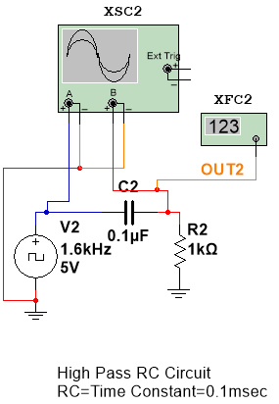

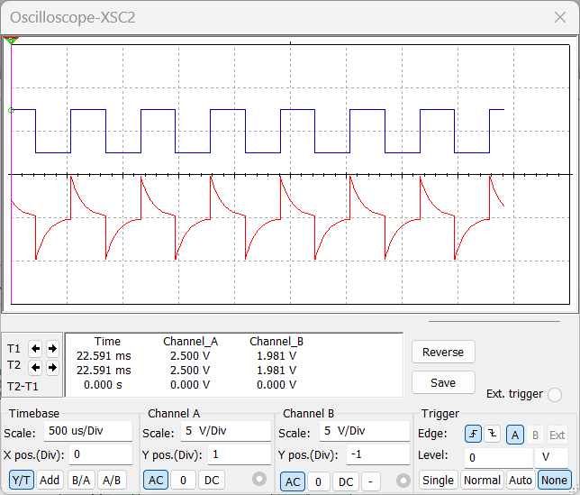

**Figure 4. High pass RC when (RC =T) time constant=0.1msec and transient response**

1. **RC>T**

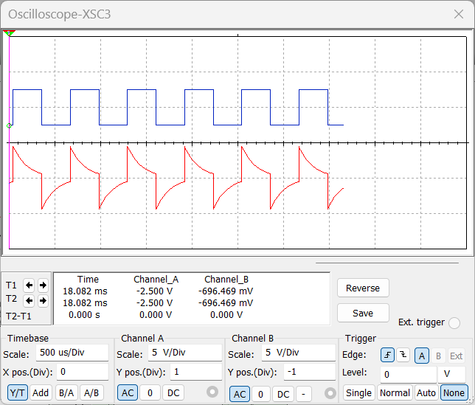

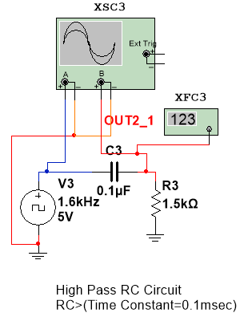

Vout

**Figure 5. High pass RC when (RC >T) time constant=0.15msec and transient response**

1. **RC>>T**

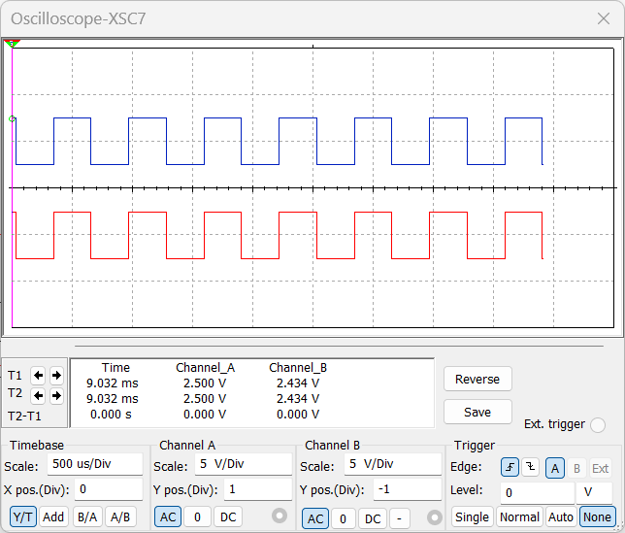

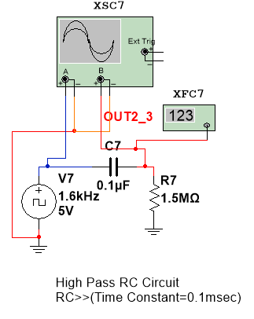

**Figure 6. High pass RC when (RC >>T) time constant=0.15sec and transient response**

1. **Low Pass RC Circuit:**

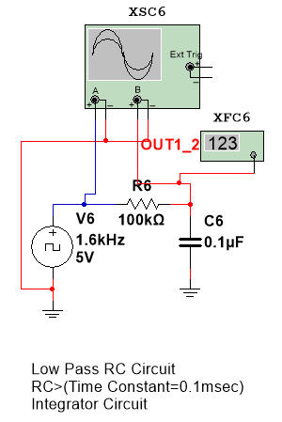

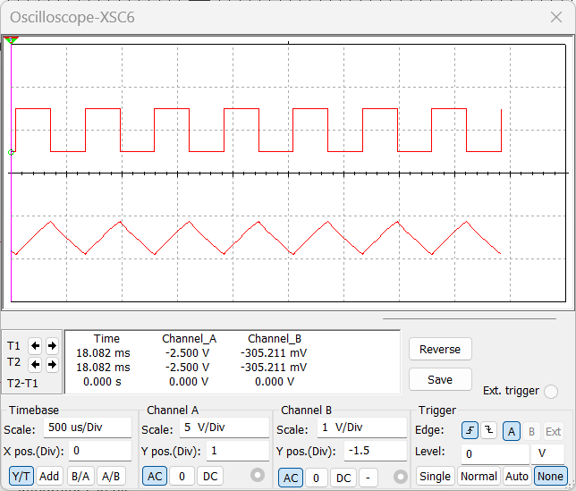

Figure 7. Low pass RC when RC >>T (INTEGRATOR CIRCUIT) and transient response

**Conclusion:**

The above waveform depicts the integrator behavior of RC Circuit, as we can see the input square wave is modified and produced triangular waveform at its output. Here RC time constant is very large, so the charging/discharging of capacitor takes a lot of time thus producing linear increasing and decreasing graph this waveform is same as a triangular waveform. As Time constant(τ=RC) increases the triangular waveform sharpens. Thus we can generate triangular waveform using a Low pass RC Circuit operating at RC>>τ.

[Low Pass RC Circuit operating at RC>>τ = Triangular Wave Generator]

1. **RC=T**

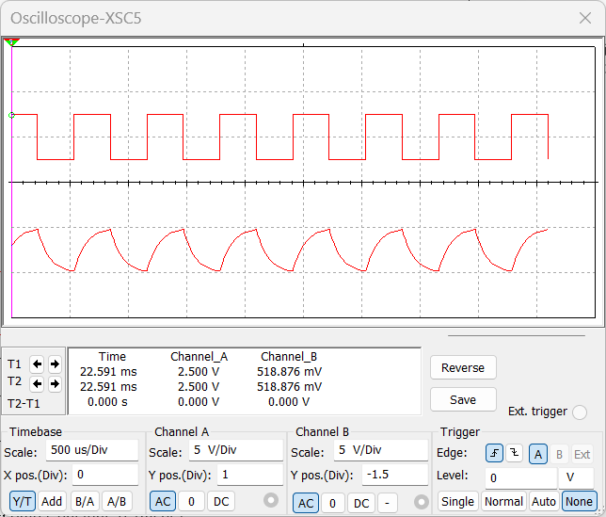

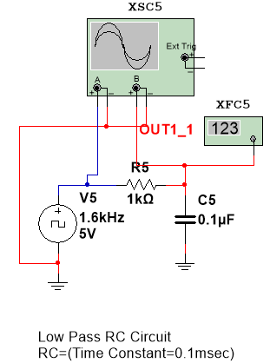

**Figure 8. Low pass RC when (RC =T) time constant=0.1msec and transient response**

1. **RC<T**

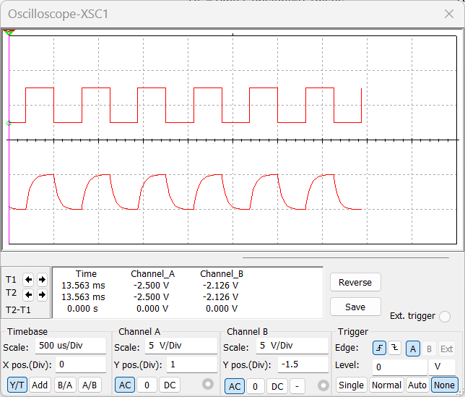

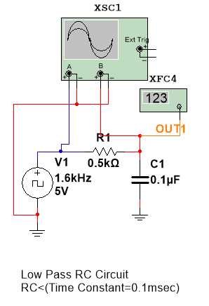

Vout

**Figure 9. Low pass RC when (RC <T) time constant=0.05msec and transient response**

1. **RC<<T**
2. **RC<<T**

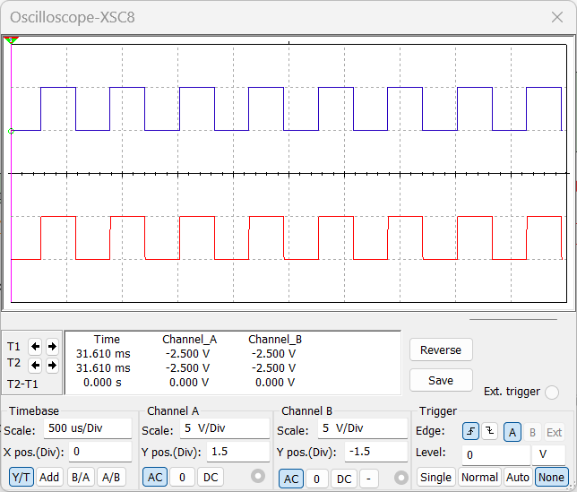

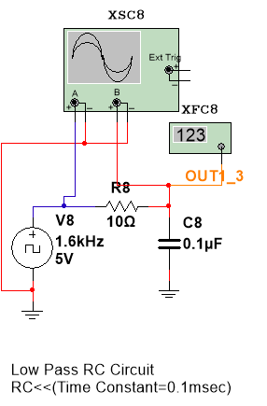

**Figure 10. Low pass RC when (RC <<T) time constant=0.1µsec and transient response**